About:

DIY provides a selection of freshly brewed tea Infused with different natural flavors. We have bubble milk tea, fruit tea, coffee and popcorn chickened. We brew our tea fresh every morning, using pure tea leaves directly imported from Taiwan. Grab a quick and filling snack on the go, or relax and enjoy it in our lounge.

Open:

|  |  |
| --- | --- |
| Fri | 12:00–20:00 |
| Sat | 12:00–20:00 |
| Sun | 12:00–21:00 |
| Mon | 12:00–21:00 |
| Tue | 12:00–21:00 |
| Wed | 12:00–21:00 |
| Thru | 12:00–20:00 |

[Passion Fruit Green Tea](javascript:void(0)) $4.71

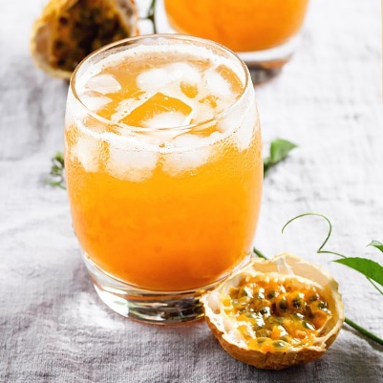

[Hawaii Fruit Tea](javascript:void(0)) $4.71

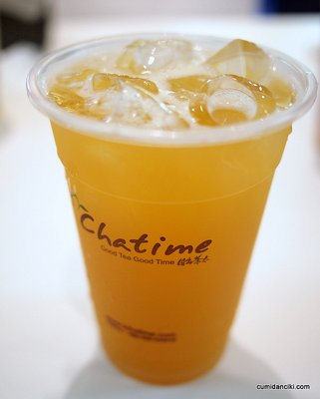

[Large DIY House Special Milk Tea](javascript:void(0)) $5.2

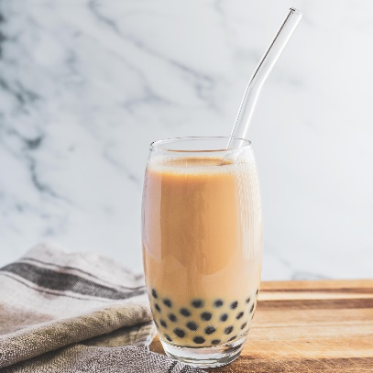

[Large DIY Black Milk Tea](javascript:void(0)) $4.95

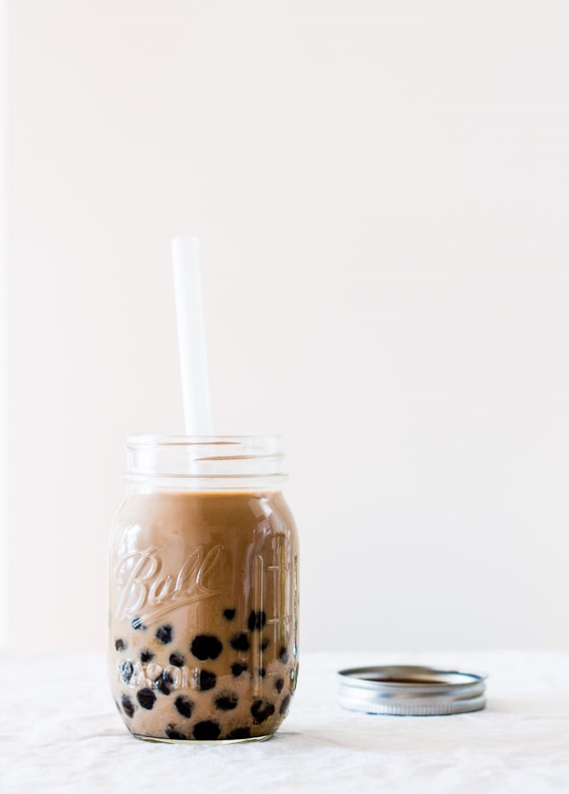

[Large DIY Green Milk Tea](javascript:void(0)) $4.95

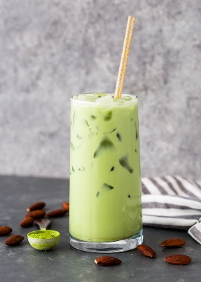

[Large DIY Brown Rice Milk Tea](javascript:void(0)) $4.95

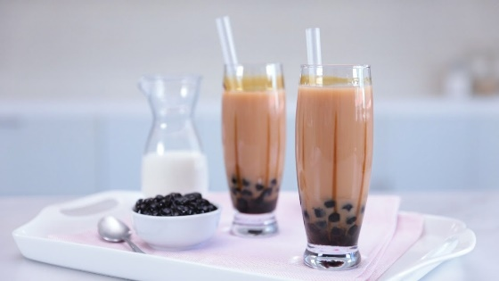

[Large DIY Thai Tea](javascript:void(0)) $4.95

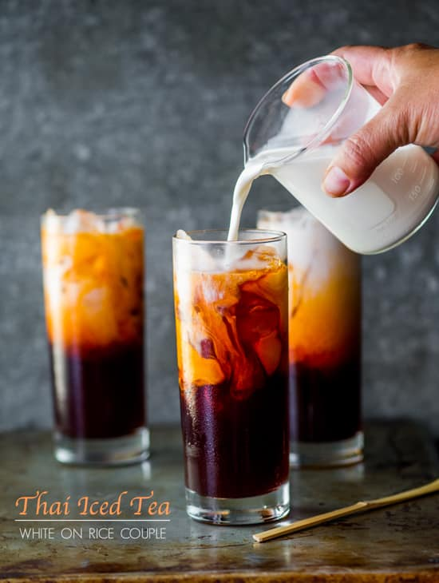

[Large Oolong Milk Tea](javascript:void(0)) $4.95

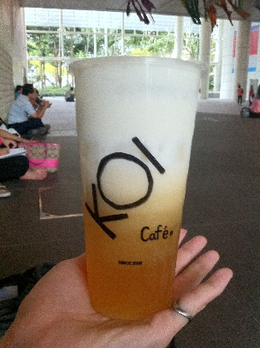

[Large Oolong Tea](javascript:void(0)) $4.21

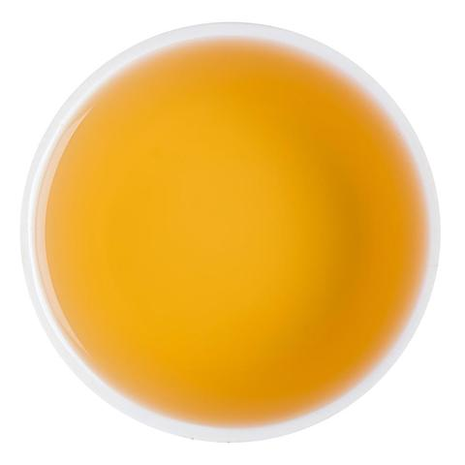

[Roasted Oolong Tea Kreama](javascript:void(0)) $5.2

